SMART MONITORING WELL CONSTRUCTION
What not to do!
To accurately evaluate ground water over time for characterization and monitoring purposes, the well construction must allow for evaluation of the zones and parameters of interest. This is a basic premise that is very often overlooked. A common example of this issue is when the zones of interest are unknowingly cased. In the example on the reverse side, the well illustrates an actual case where the zones that needed to be monitored were prevented from flowing into the well because those intervals were blocked with blank casing. As illustrated in the montage, the screened interval was open to depths which were not hydraulically conductive.
In this case, the work scope requirements stipulated a screen zone of 10 ft, based exclusively on drilling, without regard to the any borehole logging results. In this case, field data from logging were acquired and suggested that in order to capture the flow zones, a longer interval should be screened. In addition, the intervals of the aquifer that should be monitored were identified by hydrophysical logging – however, even though these intervals varied from what had been stipulated in the work plan, the work plan was followed – resulting in the placement of screen over zones which would not accurately allow access to the groundwater intervals of interest.
This completion resulted in the zones of interest being cased over – therefore, groundwater monitoring would not effectively capture the data from the zones of interest because the flow is not entering the well, but is blocked by the casing.
In this situation, both logging and well construction were ultimately a waste of time and money. The logging results were ignored, and the well construction did not allow for actual groundwater monitoring over time. Or rather, the results which would be obtained would simply not accurately reflect or represent the zones that the regulators were attempting to assess.
● The screened zones were selected at depths based on traditional geophysical logging namely - high resistivity and low gamma responses; however, this formation (High Plains Aquifer) is complex, and use of traditional geophysical log analysis by itself was not sufficient.
● The hydrophysical logging showed flow, but these results were ignored during well design and construction
● The screened interval was “dry”.

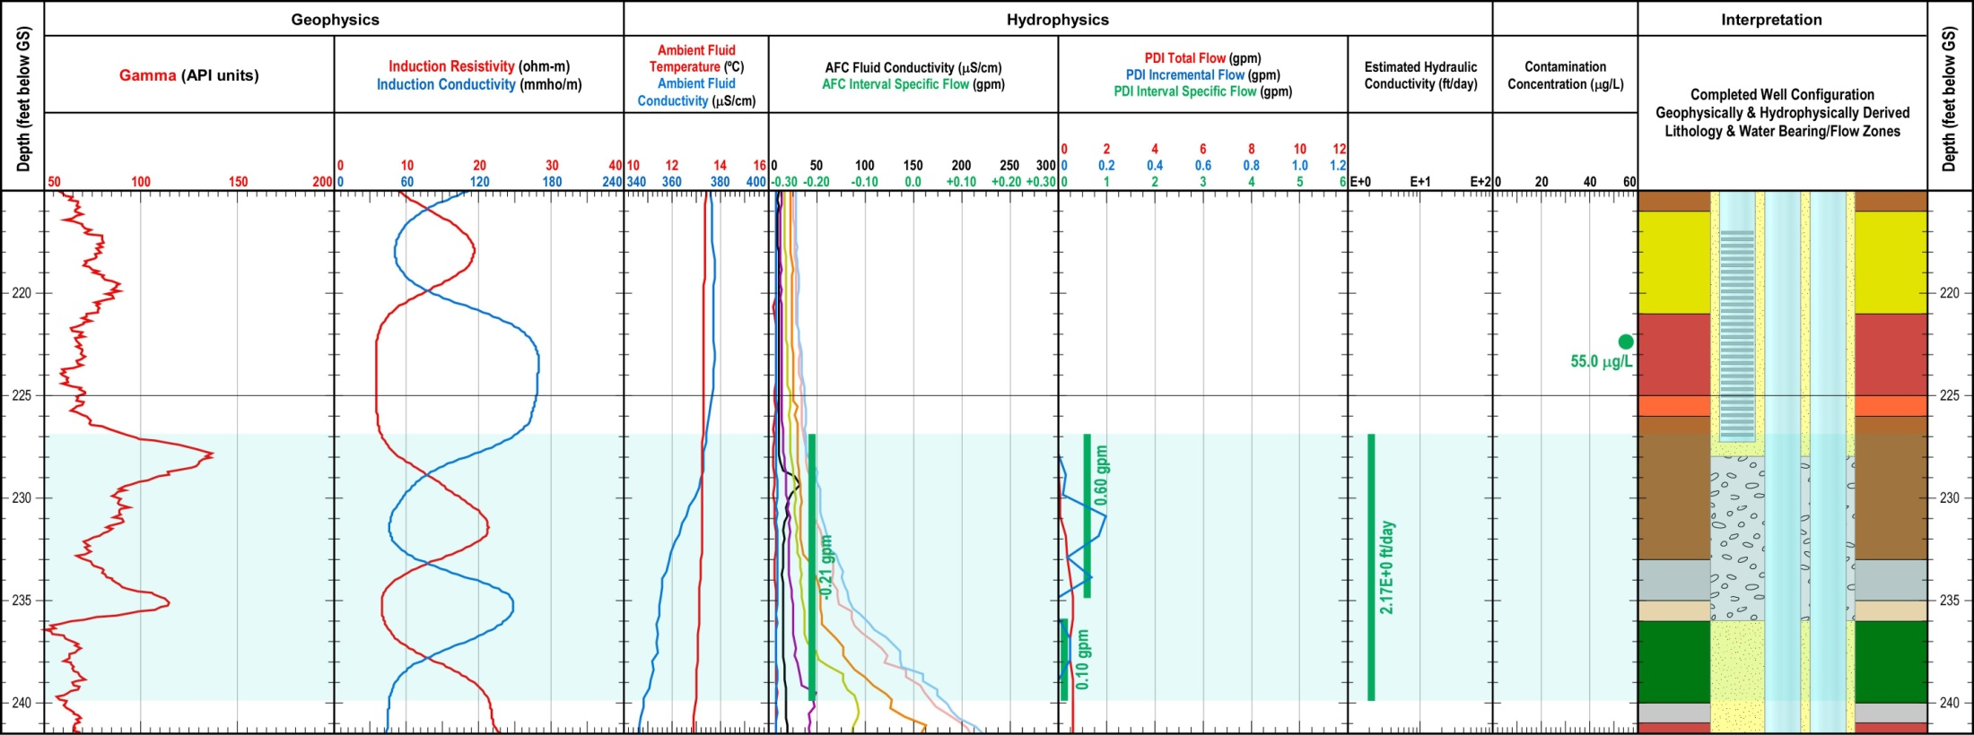

POORLY-SCREENED MONITORING WELL - This data is from a chlorinated hydrocarbon plume monitoring well placed in the Ogallala formation of Southeastern Wyoming. Multiple screens were placed into the well to monitor change in contaminant mass over time within discrete conductive features that may be contributing to the rapid downgradient transport of TCE. In this case, a conductive feature was identified by hydrophysical logging at a depth of between 227 and 240 feet. However, the screen was placed at a depth of 217 to 227 feet, virtually missing the conductive feature. As such, samples collected from within this screened interval may not be representative of the water quality in the conductive feature. TCE concentrations above and below this zone, collected prior to construction, during pumping in the fully-screened temporary well, were reported to be approximately 55 µg/L. However, after permanent well installation, because the placement of the screen did not coincide with the identified flow feature, future sample data cannot be assigned as representative of this zone.

